BALLYMAHON MUNICIPAL DISTRICT

Minutes of Meeting of Ballymahon Municipal District held in the Council Chamber, Aras an Chontae, Longford on Monday, 12th March 2018 at 4.00 p.m.

CATHAOIRLEACH: Councillor Gerard Farrell

MEMBERS PRESENT: Councillors – Mick Cahill, Mark Casey,
Colm Murray, Pat O’Toole and Paul Ross.

IN ATTENDANCE: Ms. Barbara Heslin, Director of Services.
Ms. Linda Higgins, Administrative Officer
Mr. Alan Slattery, Senior Executive Engineer.

MEETINGS
ADMINISTRATOR: Ms. Anne Lee.

SCHEDULE OF BALLYMAHON MUNICIPAL DISTRICT WORKS.

The Schedule of Ballymahon Municipal District Works, as circulated, was considered
by the members.

Councillor C. Murray proposed and Councillor M. Cahill seconded that a letter be forwarded
to the Minister for Transport and the TII regarding the cut in road maintenance funding for
2018 from TII.

The following issues were raised by the members –

- Safety issues on the Road from Edgeworthstown to Ballymahon.
- Cleaning of gulleys.
- Safety issues at Toome Cross.
- Condition of the road adjacent to Corlea Interpretative Centre.

On the proposal of Councillor M. Cahill seconded by Councillor P. O’Toole, it was
unanimously agreed to adopt the Schedule of Ballymahon Municipal District Works,
as circulated.

This concluded the business of the meeting.
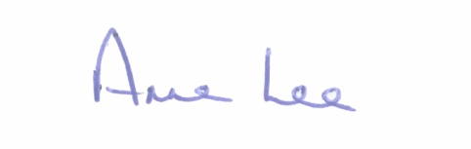
Signed: _______________
Anne Lee,
Meetings Administrator.

Confirmed and adopted at Ballymahon Municipal District Meeting held on the
22nd March 2018.

Signed: _______________
Cathaoirleach.

